Project Quality Management

**Problem Solving Tools**

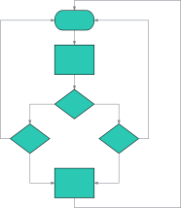

Process Flow Chart

Improve existing process or create new process

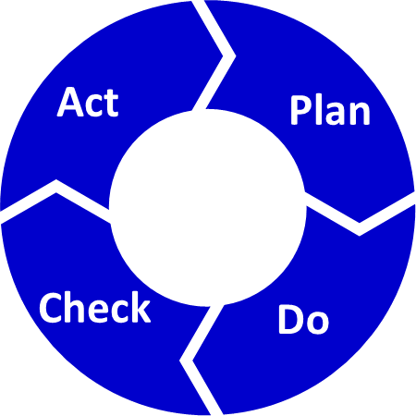

PDCA

Iterative approach to implementing change



Brainstorming / Brainwriting

Generation of ideas or solutions

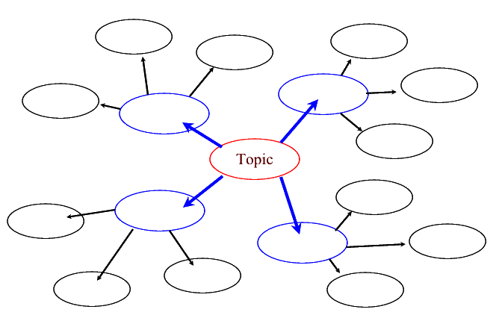

Mind Mapping

Visual brainstorming for quick capture



Affinity Diagram

Organize information from brainstorming activity

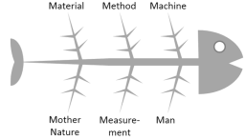

Cause & Effect Diagram

Breakdown complex issue and identify root causes by area